Lab Exercise 3 :

Student Survey: Simple Linear Regression using Scikit Learn, OLS, and Parameter Saving

Aim
To collect real-world student survey data using Google Forms, preprocess and clean the dataset, perform Simple Linear Regression using Scikit-learn, manually compute the regression equation using Ordinary Least Squares (OLS) formulas, compare both approaches, and save the learned model parameters.
Instructions
- During the first 15 minutes of the lab session, fill out the Google Form shared, link :
MCA- https://docs.google.com/forms/d/e/1FAIpQLSf5FiV9cUhcPSVk3emXvAndNb7xCxNsAT4pN3noiIa0sc0qSA/viewform
- Ensure that responses are collected from your classmates.
- Export the responses into CSV format.
- Use the collected dataset for all further analysis
Suggested dataset name:
student_survey.csv
Problem Statement
Using the dataset collected from the class survey form, perform Simple Linear Regression analysis to determine whether:
- CIA percentage can predict GPA
- Attendance percentage can predict GPA
You are required to perform regression in two different ways:
- Using Scikit learn Linear Regression
- Manually using the mathematical equations of slope and intercept derived from Ordinary Least Squares (OLS)
Finally, compare the outputs obtained from both methods and save the learned model parameters.

Refer this for getting and understanding : https://colab.research.google.com/drive/1No__uEMN0sq8y2oqGvRgL9FKMGAp7BxX#scrollTo=a7bfa6e8
Tasks to Perform

Part A: Data Collection and Preprocessing
Perform the following steps:
- Load the dataset using Pandas
- Display the first 5 rows
- Check dataset dimensions
- Identify missing values
- Remove or handle null values
- Convert required columns into numerical datatype
- Remove duplicate records if present
- Generate statistical summary
- Select appropriate dependent and independent variables

Regression Experiments: Experiment 1
Independent Variable (X):
CIA Percentage
Dependent Variable (Y):
GPA

Experiment 2
Independent Variable (X):
Attendance Percentage
Dependent Variable (Y):
GPA
Part B: Simple Linear Regression using Scikit-learn
Perform the following:
- Split the dataset into training and testing sets
- Train the model using LinearRegression from Scikit learn
- Obtain:
  - Slope
  - Intercept
- Predict output values using the trained mod
Part C: Manual Computation using Ordinary Least Squares (OLS)
Using the same dataset, manually compute the regression line using the OLS formulas given below.
Refer : 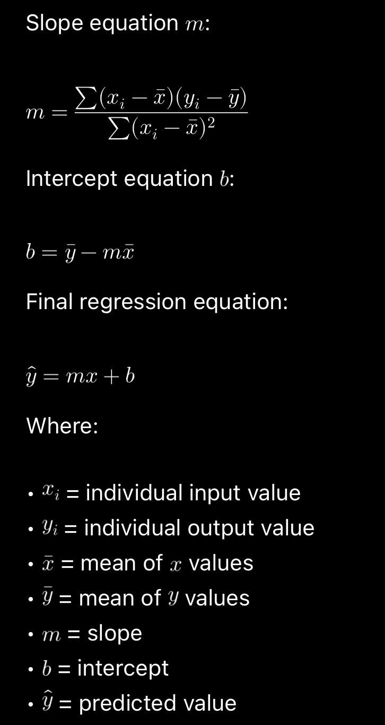Manual Regression Equation
Construct the regression equation manually using the computed slope and intercept values.
Comparison Task
Compare the following:
- Predictions from Scikit learn
- Predictions from manually computed OLS equation
- Difference between both outputs
Provide observations regarding whether both methods produce similar results.

Parameter Saving Task
Save the parameters learned by the model using Pickle.
The following parameters must be saved:
- Slope
- Intercept
Suggested file name:
linear_regression_weights.pkl
Demonstrate:
- Saving parameters into Pickle file
- Loading the Pickle file
- Using loaded parameters for prediction
Expected Output
Submit the following:
- CSV dataset
- Data preprocessing notebook
- Scikit learn regression implementation
- Manual OLS calculation( self study )
- Comparison of both approaches
- Pickle file containing saved parameters
- Final observations and inference
Sample Viva Questions
- What is Simple Linear Regression?
- What is the role of slope and intercept?
- What is Ordinary Least Squares?
- Why do we square the errors in OLS?
- Difference between dependent and independent variable
- Why should data be cleaned before training?
- Why are slope and intercept called model parameters?
- Why do we save learned weights?
Note for your reference use these two-demo links: -

1.https://colab.research.google.com/drive/1No__uEMN0sq8y2oqGvRgL9FKMGAp7BxX#scrollTo=a7bfa6e8

